**Publishing a Document to the Portal Library**

**Overview**

This guide provides instructions for creating user facing Data and Analytics Platform (DAAP) documents. It also covers the process for publishing both **new documents** and **edits to current** documents to the Data and Analytics [Portal Library](https://analytics.kroger.com/docs/). Below you will find two different templates to choose from and the purpose for each.

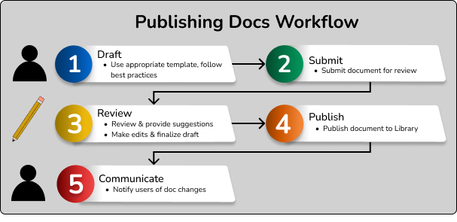

*Figure 1* – Publishing workflow

**Instructions – New Document**

**Step 1 – Select Template**

1. Sign into the [Data & Analytics Portal Library](https://analytics.kroger.com/docs/)

* Only the user that submits the draft can edit the draft
* If additional users require edit access, reach out to the AE team via [Teams](https://teams.microsoft.com/l/channel/19%3a9a7fa5aa162e4db1887004bbafe93720%40thread.tacv2/Writing%2520Support?groupId=dc67574d-f0e2-4915-94c0-000a19c8202e&tenantId=8331e14a-9134-4288-bf5a-5e2c8412f074) or [email](mailto:AnalyticsEnablementSupport@kroger.com)

1. Navigate to the *My Documents* button and click on the *Create* document link

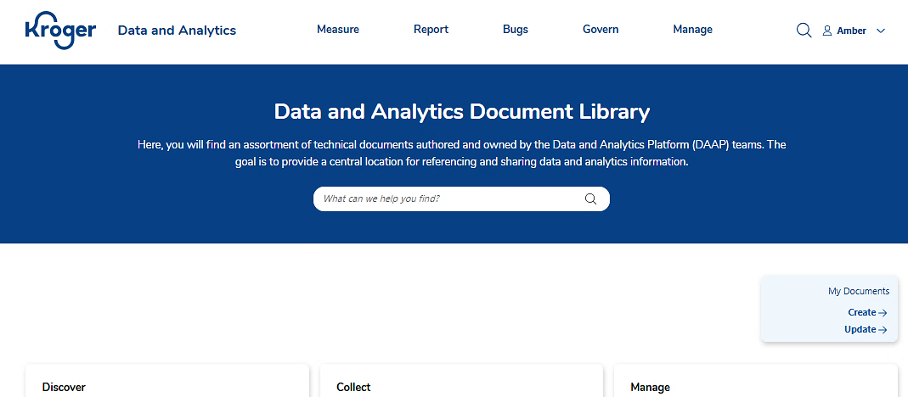

*Figure 2* – Library landing page

1. Select the template based on the purpose of your document

|  |  |
| --- | --- |
| **If the purpose of the document is to** | **Then** |
| Explain **How** to complete a process, do a task, or describe how something works. E.g., user guides, job aids, SDK docs | Use the Instructional template |
| Describe **What** a product, tool, or service is or what it does - it’s functionalities, benefits, and uses. E.g., product overviews, company policies | Use the Informational template |

* All documents have the following five parts:
  + **Title** –A brief, insightful name for the document (try starting with an -ing verb)
    - * + **Overview** – Introduces topic, identifies audience, sets expectations, names requirements
        + **Instructions/ Information** – Body of the document that informs (the what) or instructs (the how)
        + **Resources** – Links to important documents, tools, and sites. Provides options for support and feedback

**Summary** –A shortened version of the overview. **108 character max**. This serves as the doc preview in the Portal Library.

* + - * + **Version History** – Includes version number, date, description of changes, and author

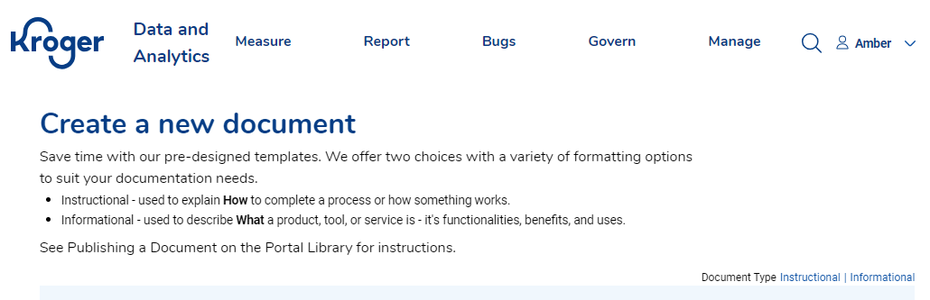

*Figure 3* – Create a new document page

**Step 2 – Create Draft**

1. Draft document following writing best practices:

* Write a **clear** document that readers can understand
* Use proper grammar
* Define unfamiliar terms, and avoid excessive acronyms, abbreviations, and jargon
* Ensure document is **concise**
  + Keep words and sentences short, and eliminate pleasantries
  + Write in active voice and use present tense (start with a verb)
* Confirm document is **comprehensive**
  + Think in terms of “Trigger to Target” – What Triggers the ***Action***? What is the targeted ***Outcome***?
  + Avoid assumptions with reader knowledge and understanding for a complete doc
* Aim for **consistency** 
  + Use consistent headers, fonts, bulleting, and tone
  + Use industry-familiar terms and avoid over-interchanging terminology
* Verify document and the information contained within is **compliant**
  + Adhere to technical writing best practices, templates, and established standard operating procedures
  + Consider company, local, state, & federal regulations related to data and analytics

1. Add in code blocks, images, links, and infographics to the document to provide clarity to the reader
2. Click *Save* to finish draft later, or move to Step 3

* **You must click the *Save* button to save the document. Autosave is not enabled**

**Step 3 – Submit Draft**

Click on the *Review* button to submit the document for technical writer review

|  |  |
| --- | --- |
| **If tech writer** | **Then** |
| **Does not** have  any suggestions for improvement | Tech writer clicks the *Publish* button to move the document to the Portal Library in the agreed upon category   * The document will be live in the library within [ ]. |
| Has suggestions for improvements and clarity | Tech writer clicks the *Review* button to send the document, with added suggestions or questions, back to the owner for resolution |

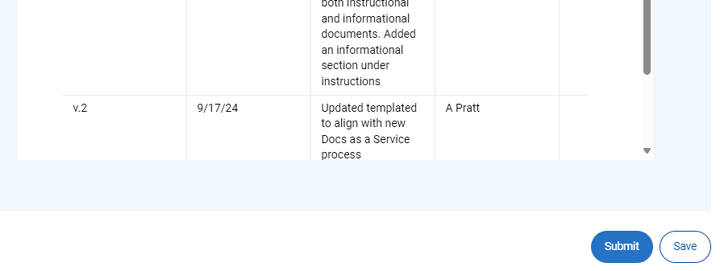

*Figure 4* – Submit or save document

**Step 4 – Approve document**

Review the highlighted changes or added questions made to the document

|  |  |
| --- | --- |
| **If you** | **Then** |
| Agree with the document suggestions | 1. Click the *Review* button to send the document back for publication 2. Technical writer publishes the document to the Portal Library in the agreed upon category  * The document will be live in the library within [ ]. |
| Need to make more edits to the document | 1. Make the needed revisions in the document 2. Click on the *Review* button to submit the document for technical writer review 3. Repeat the process with the tech writer to finalize the draft for publication 4. Technical writer publishes the document to the Document Library in the agreed upon category |

**Instructions – Edit Existing Document**

**Step 1 – Locate document**

1. Sign into the [Data & Analytics Portal Library](https://analytics.kroger.com/docs/)
2. Navigate to the *My Documents* button and click on the *Update* link
3. Click on the document from your list that requires the edits

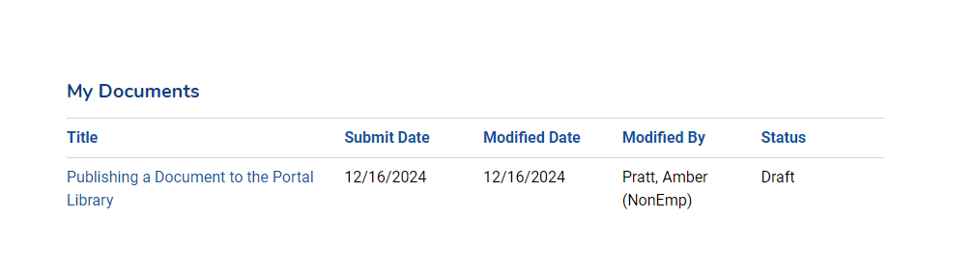

*Figure 5* – My Documents

**Step 2 – Prepare edits**

1. Complete the revisions following the best practices noted in Step 2 of the *New Document* section
2. Click *Save* to finish draft later, or move to Step 3

* **You must click the *Save* button to save the document. Autosave is not enabled**

**Step 3 – Submit edited doc**

Click on the *Review* button to submit the document for technical writer review

|  |  |
| --- | --- |
| **If tech writer** | **Then** |
| **Does not** have  any suggestions for improvement | Tech writer clicks the *Publish* button to move the document to the Portal Library in the agreed upon category   * The document will be live in the library within 1 hour. |
| Has suggestions for improvements and clarity | Tech writer clicks the *Review* button to send the document, with added suggestions or questions, back to the owner for resolution |



**Step 3 – Approve edits**

Review the highlighted changes made to the document

|  |  |
| --- | --- |
| **If you** | **Then** |
| Agree with the document suggestions | 1. Click the *Review* button to send the document back for publication 2. Technical writer publishes the document to the Portal Library in the agreed upon category  * The document will be live in the library within 1 hour. |
| Need to make more edits to the document | 1. Make the needed revisions in the document 2. Click on the *Review* button to submit the document for technical writer review 3. Repeat the process with the tech writer to finalize the draft for publication 4. Technical writer publishes the document to the Document Library in the agreed upon category |

**Resources**

**Summary**

Guidelines for writing, editing, and publishing a Data and Analytics Platform doc to the Portal Library

**Documents**

* Informational template
* Instructional template

**Support**

Teams – Analytics Enablement Writing Support

Email – @kroger.com

* Subject line - *Writing Support*

**Version History**

|  |  |  |  |
| --- | --- | --- | --- |
| **Version** | **Date** | **Description** | **Author** |
| v1.0 | 6/8/23 | Initial Version | A Pratt |
| v1.1 | 8/22/23 | Step 2.c & d - Added "information" to make these instructions apply to both technical instructions and information documents. | A Pratt |
| v1.2 | 12/21/23 | * Replaced references to the CMS with Document library. * Step 2 - Added step e. * Step 4 - Updating with instructions for editing document | A Pratt |
| v.2 | 1/29/24 | Added Step 5 instructions for archiving / deleting a doc | A Pratt |
| v2.1 | 9/27/24 | Updated instructions to align with the new Docs as a Service process and doc library | A Pratt |